Alt_Config System
The Alt_Config system was added to simplify the comparison and editing of models which need flags to turn rules and operations on and off.
The system consists of a block of code in the Alternative_Setup_Init script which reads through a series of text files to set values that can be read with altSetupSV.varGet(“key”) calls. There are no safeguards to check that altSetupSV values are overwritten, so the alt_config values are read in first and will be overwritten if a variable of the same name created later in the Alternative_Setup_Init script. This ensures that the user cannot create a key that will break other model functionality.

Default Files and Alternative Files
The files read are located in the $WATERSHED/scripts/alt_config directory. Inside of this, there is a default file and alternative-specific text files. The alt_config code will first read the watershed defaults file, then overwrite any values from the default with ones found in the current alternative’s file. Thus, a default value should be used to provide backwards compatibility, rather than adding values to previous alternatives. Only the alternative where the variable takes an unusual value shows the change.

Key:Value formatting
The text files are delimited by a colon between the key and value, with a separate pair on each row. The text files are read in a variant of the JSON syntax, called HJSON (Human-readable JSON, hjson.org) that is more forgiving. The alt_config files act like a Python dictionary, and elements can be defined as combinations of Python scalar values, dictionaries and lists. The key strings are case-sensitive! Boolean values should be entered in JSON format, as true or false, without quotes around them. None can be entered as null. Comments may be included if they start with a pound sign. Do not include units unless a string is desired. maxAdjGCL: 3 will cause the integer 3 to be stored in AltSetup. maxAdjGCL: 3 MAF will store “3 MAF” in AltSetup. If a key is not found, it will return None. For example, altSetupSV.varGet(“unknownKey”) will return None if unknown key is undefined.

Adding new alt_config variables in code
When adding a new alt_config variable in a piece of code, the default value should be added to the network or watershed default.txt file that handled in a way that does not alter the behavior of the other alternatives. This should prevent changes to the existing model output. The default value may depend on how the new variable is being used.
Code should not assume that a default value exists. Any code that references an alt_config variable should check that a key has been set before referencing it. Not checking for the existence of a variable can introduce errors in existing code. For example, calling release = min(release, altSetupSV.varGet(“newMinFlowRequirement”))will set release to None if newMinFlowRequirement not defined for the given alternative. This will cause problems with existing code that expects a defined value for newRelease. New code should also include a test for the key being undefined, preferably with:
if altSetupSV.varExists(“newMinFlowRequirement”):
minFlowReq = altSetupSV.varGet(“newMinFlowRequirement”)
release = min(release, minFlowReq)
or (less preferable) after reading the variable:
minFlowReq = altSetupSV.varGet(“newMinFlowRequirement”)
if not minFlowReq is None:
release = min(release, minFlowReq)
When using either approach, a default value being undefined would not impact the results.

Nested Values
For dictionaries or lists, the value of each item at the root level is stored as a local variable for the Alternative Setup state variable. An entry such as “tempRuleAtDWR: {“start”:“Jun”, “end”:“Sep”, “max”:14.5, “gasCap”:true}” could be accessed from any script with access to the Alternative Setup state variable using altSetupSV.varGet(“tempRuleAtDWR”), and would contain the python dictionary defined in the file, with two strings, a float, and a Boolean value. In this example, the entire dictionary needs to be replaced if the default is changed. Individual elements are not replaced if an alternative specific file over-rides the default file.

Alt_Config report
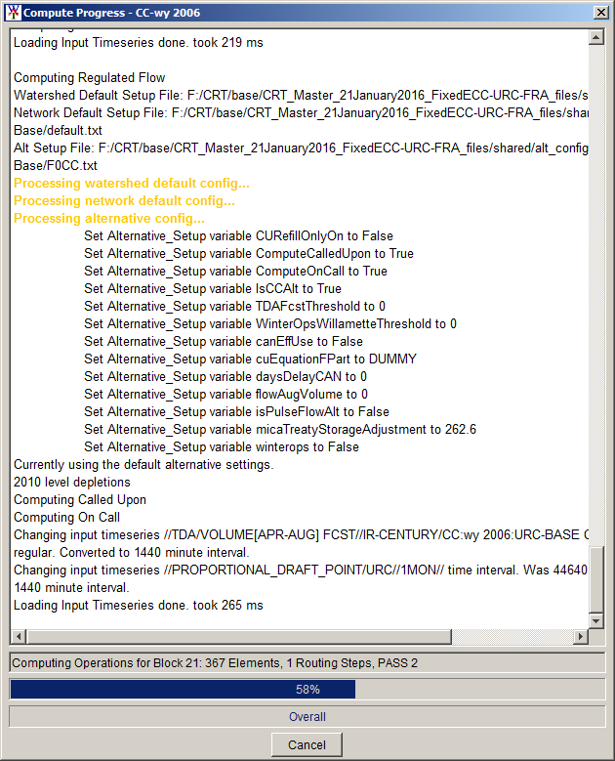
After ResSim reports “Computing Regulated Flow”, the AltConfig code prints the files it is reading in for the configuration, and then a report of the variables that were read in, and what value they were set to. The variable name is in the format used within the model, and the value is in Python format, for example, Boolean values are written in Python case (True instead of true). The log file produced by the WAT compute will also contain this information.
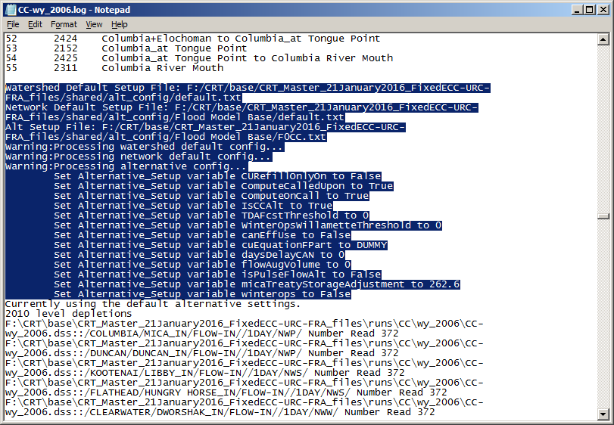’

Aliasing another alternative’s file
In the event that an alternative should always be mapped the same as another alternative, a text file with: @alias <alternative name> as the first line will force the alt_config code to read from the file with that alternative name instead. All other lines in the alias file will be ignored. This has been used in the past for alternatives with different settings in the ResSim alternative editor, but should maintain the same configuration file.

